In this assignment we were tasked with retrieving raw data from the Openweather API and break it out into useful informative data and graphs. After doing this, we were then tasked with filtering our data down to a list of potential Vacation destinations we would likely want to visit due to ideal weather conditions we set ourselves. Furthermore, we were tasked with uploading our data to a navigable website. Below are my findings as well as a link to the functional website:

**Website:** <https://wooteenie.github.io/Weather-Analysis/Web-Design-Challenge/Resources/index.html>

1. It does appear true that the closer a location is to the Earth’s equator, the higher it’s max temperature is. Outside of this, there weren’t many other strong correlations to wind speed, humidity levels, or cloudiness:

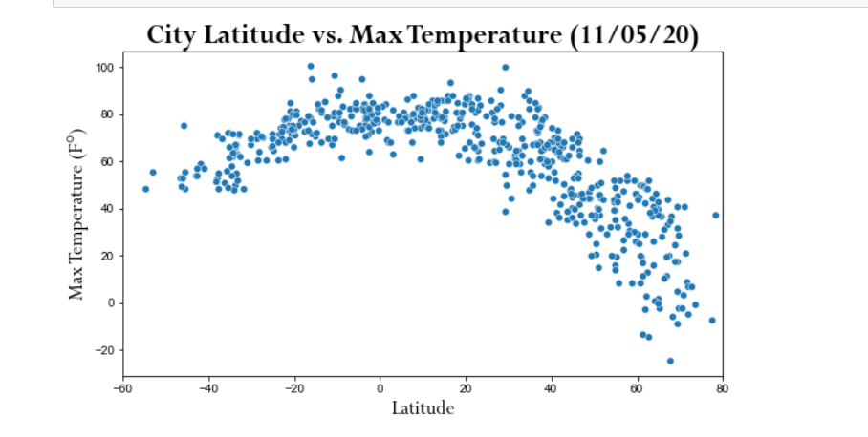

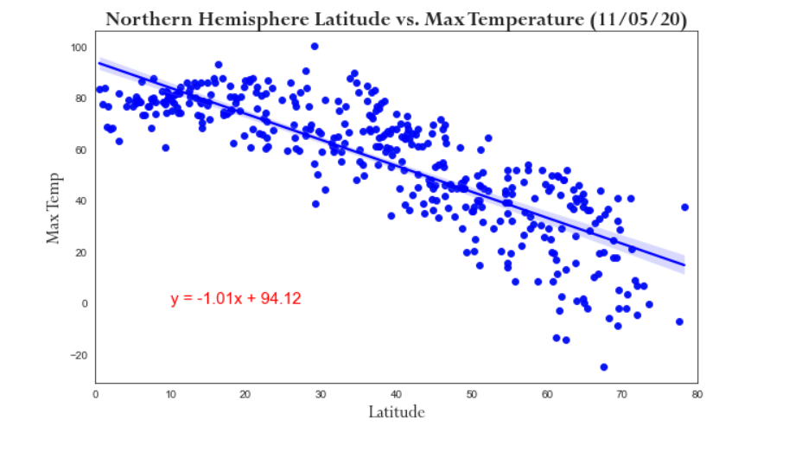

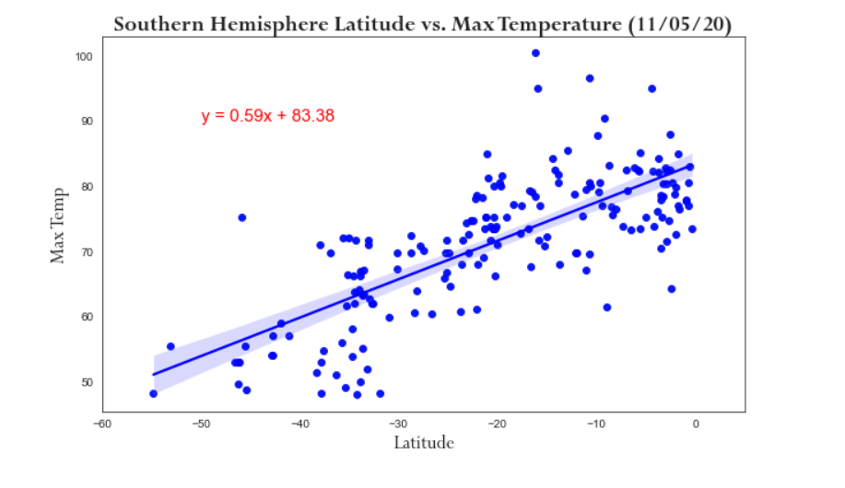

1. My wife and I really like the beach! And when we go, we really like the temp to be between 85 and 70 degrees with a small breeze to wick away any sweat. We also don’t want too much humidity, otherwise we feel super sticky. And who wants clouds on their beach vacation? We usually want just enough to find some shade when it gets too hot. Given that criteria, it looks like we may be taking our next beach vacation in California!

